SYSTEM REQUIREMENTS SPECIFICATION AND STATEMENT OF WORK

**Project Name:** SERVICESRUS’s “one stop marketplace” Website

**Product:** Website

**Team:**

**Prepared By**

|  |  |
| --- | --- |
| **Document Owner(s)** | **Project/Organization Role** |
| Liangmou Zhang |  |
|  |  |
|  |  |

**Document History & Versioning**

|  |  |  |  |
| --- | --- | --- | --- |
| **Version** | **Date** | **Author** | **Change Description** |
| 1.0 | 01.23.2019 | Liangmou Zhang |  |
|  |  |  |  |
|  |  |  |  |

.

**TABLE OF CONTENTS**

**PROJECT CHARTER** **4**

Project Background 4

Problem Statement 4

**PROJECT GOALS** **4**

Goals & Objectives 4

Assumptions & Constraints 4

List of Terms & Conventions 4

Requirements Elicitation Approach 5

Requirements Management Plan 5

**USER REQUIREMENTS** **5**

Actors 5

Use Cases 5

UCXXX: Title of Use Case 5

**SYSTEM REQUIREMENTS** **6**

Functional Requirements 6

Non-Functional Requirements 6

**WORKFLOWS & PROCESS MODELS** **7**

Workflow: Use Case Title 7

Workflow: Use Case Title 7

**DATA REQUIREMENTS** **7**

Data Dictionary 7

Data Model 7

**USER INTERFACE REQUIREMENTS** **7**

SCXX: Screen Name 7

Navigation Map 7

**PROJECT CONTROLS** **8**

Use Case Prioritization 8

Risks 8

Issues 8

Schedule 8

Cost Estimate 8

References 8

**REQUIREMENTS APPROVALS** **8**

**APPENDICES** **9**

Source Material 9

# 

# PROJECT CHARTER

## Project Background

The client identified a chance to compete in personal services market. The client wants to create a marketplace where users can search services based on their geographical location.

## Problem Statement

The problem of design, develop and host a website affects SERICESRUS, (the client). The impact of which is users can search for services based on their geographical location. A successful solution would be building an user-friendly website with an intuitive interface.

# PROJECT GOALS

## Goals & Objectives

Design a website which must be Easy and intuitive, visually pleasing, informative, safe and secure, quick to load and operate.

Objective is to continue to build brand identity, awareness, and interest in the organization and the services it provides.

## Assumptions & Constraints

### 2.2.1 Assumptions:

1. Maximize web-based technologies

2. Provide focused web-based solutions

3. Increase market share

### 2.2.2 Constraints: time, accuracy, information depth

## List of Terms & Conventions

|  |  |
| --- | --- |
| Term | Definition |
| Service client | Users who use the system to search for services |
| Service provider | People who are will to provide the services |
|  |  |

|  |  |
| --- | --- |
| Acronym | Definition |
| SV | Service client |
| AP | Administrator Personnel |
| SP | Service provider |

## Requirements Elicitation Approach

[State here how you plan to collect requirements and from whom.]

## Requirements Management Plan

[State here how you plan to manage the requirements and where they will be stored.]

# USER REQUIREMENTS

## Actors

|  |  |
| --- | --- |
| Actor | Description |
| Service clients | Can search for providers who provide services. |
| Front-end developer | People working on the interface between user and back end. |
| Safari | Web system used as an interface for clients to search for services. |
| Service providers | People wants to provide service to the clients. |

* + 1. **Role Map**

## Use Cases

[List the use cases, i.e. the main uses of the systems. Define each use case with a short description; the actual details should be defined in the sections below.]

|  |  |  |
| --- | --- | --- |
| ID | Use Case | Brief |
| UC1 | Clients search for services | Clients can search for providers by answering questions. |
| UC2 | Administration personnel update user profile | Administration personnel can create, update, delete any user. |
| UC3 | Administration personnel adds questions to service type | Clients can create, update, delete questions for different service types. |

### UC1: Client search for providers

|  |  |  |  |  |  |  |  |
| --- | --- | --- | --- | --- | --- | --- | --- |
| **Identifier:** | ***UC1*** | **Use Case Title:** | | | Clients search providers | | |
| **Actors:** | Service clients, Service providers, System | | | | | | |
| **Level:** | Detailed | | **Frequency:** | Daily | | **Duration:** | Minutes |
| **Description:** | Clients search for providers by answering questions particular to that type of services. Questions are different and answers are filtered to provide the right service to the right client. | | | | | | |
| **Pre Conditions:** | * User must log in * Answers must be answered * Providers must be existed | | | | | | |
| **Basic Path:** | 1. Service clients who wants services logs in to the system 2. Service clients answers the questions 3. Questions are filtered 4. Available services providers are shown to the user 5. Service clients selects agreeable provider and view its information 6. Service clients can ask service providers to bid for a particular job 7. Service clients with one best fit provider can come to an agreement | | | | | | |
| **Variations:** | V1: Service clients can search by answering questions, type at search bar or selecting from a set of services. | | | | | | |
| **Post Conditions:** | *Success*:   * Client signed with the selected service provider.   *Failure*:   * The provider decides not to provide the service to the agreed client. * The client decides not to sign the service with the agreed provider. | | | | | | |
| **Link to Activity Diagram:** | Reference the section containing the activity diagram for this use case | | | | | | |
| **Link to UI Storyboard:** | Reference the section containing the UI storyboard/mock-up for this use case | | | | | | |
| **Special Requirements:** | List any unique requirements for this use case | | | | | | |
| **Open Issues/Notes:** |  | | | | | | |

### UC2: Administration personnel update user profile

|  |  |  |  |  |  |  |  |
| --- | --- | --- | --- | --- | --- | --- | --- |
| **Identifier:** | ***UC2*** | **Use Case Title:** | | | Administration personnel update user profile | | |
| **Actors:** | Administration personnel, System | | | | | | |
| **Level:** | Detailed | | **Frequency:** | Daily | | **Duration:** | Minutes |
| **Description:** | Administration personnel is able to modify account and personal information for all users in the system. | | | | | | |
| **Pre Conditions:** | * There must be people using the system | | | | | | |
| **Basic Path:** | 1. Administration personnel logs in to the system  2. Administration personnel looks at information provided  3. Administration personnel update user information | | | | | | |
| **Variations:** | V1: Provided information may be what personnel really want  V2: There may be too much information provided | | | | | | |
| **Post Conditions:** | *Success*:   * Personnel gathered/classify information and update the profile   *Failure*:   * Personnel failed to update the profile because of system bugs * Information provided by provider are fake | | | | | | |
| **Link to Activity Diagram:** | Reference the section containing the activity diagram for this use case | | | | | | |
| **Link to UI Storyboard:** | Reference the section containing the UI storyboard/mock-up for this use case | | | | | | |
| **Special Requirements:** | List any unique requirements for this use case | | | | | | |
| **Open Issues/Notes:** |  | | | | | | |

### UC3: Administration personnel adds questions to service type

|  |  |  |  |  |  |  |  |
| --- | --- | --- | --- | --- | --- | --- | --- |
| **Identifier:** | ***UC3*** | **Use Case Title:** | | | Administration personnel adds questions to service type | | |
| **Actors:** | Administration personnel, System | | | | | | |
| **Level:** | Detailed | | **Frequency:** | Daily | | **Duration:** | Minutes |
| **Description:** | Administration personnel can add questions for different services. So that client can answer these questions to get the most accurate search result. | | | | | | |
| **Pre Conditions:** | * Administrator must have services provided * Administrator must have information of provided services | | | | | | |
| **Basic Path:** | 1. Administrator logs in to the system  2. Administrator edit the list of questions corresponding to different search criteria  3. Administrator adds a new question to the list  4. Administrator edit categories and assign category to a service | | | | | | |
| **Variations:** | V1: Administrator may cannot successfully add questions  V2: Information provided by providers may not be accurate  V3: Information may be too similar to classify | | | | | | |
| **Post Conditions:** | *Success*:   * Administrator adds questions to the particular service type   *Failure*:   * Administrator fails to add questions to the particular service type | | | | | | |
| **Link to Activity Diagram:** | Reference the section containing the activity diagram for this use case | | | | | | |
| **Link to UI Storyboard:** | Reference the section containing the UI storyboard/mock-up for this use case | | | | | | |
| **Special Requirements:** | List any unique requirements for this use case | | | | | | |
| **Open Issues/Notes:** |  | | | | | | |

# SYSTEM REQUIREMENTS

## Functional Requirements

|  |  |  |  |
| --- | --- | --- | --- |
| ID | Requirement | Description | Use Case |
| 1 | Display a list of questions | Questions are provided in list | UC3 |
| 2 | Display SP information | Service provider information should be successfully displayed for administrator to update and for client to look at | UC2 |
| 3 | Filter out the information | Designed system should be able to filter out the information the client not want to look at when the client answered the question | UC1 |

## Non-Functional Requirements

|  |  |  |  |
| --- | --- | --- | --- |
| ID | Requirement | Description | Use Case |
| 1 | Valid SP information | The SP information should be true and reliable. | UC1 |
| 2 | Secure SP information | The SP information should be safe and should not be able to access by others except administrator. | UC1 |
| 3 | User-friendly interface | The interface should be easy for the client to use, like no bugs, clear icons, good format and arrangement… | UC1 |
| 4 | Quick responsive system | When client search for information, the system should respond fast, especially when there is a large amount of information causing delays. | UC1 |
| 5 | Useful and accurate questions | The questions given to client to answer should be useful and accurate. No one wants to answer repeated or meaningless questions. | UC1 |

# WORKFLOWS & PROCESS MODELS

## Workflow: *Use Case Title*

[Place the activity diagram for the use case here. There is one section like this for each use case]

## Workflow: *Use Case Title*

[Place the activity diagram for the use case here. There is one section like this for each use case]

# DATA REQUIREMENTS

## Data Dictionary

|  |  |  |  |
| --- | --- | --- | --- |
| Data Element | Description | Data Type | Constraints |
|  |  |  |  |
|  |  |  |  |
|  |  |  |  |

## Data Model

[Place your class diagram(s) here…]

# USER INTERFACE REQUIREMENTS

## SC001: Administrator_UI

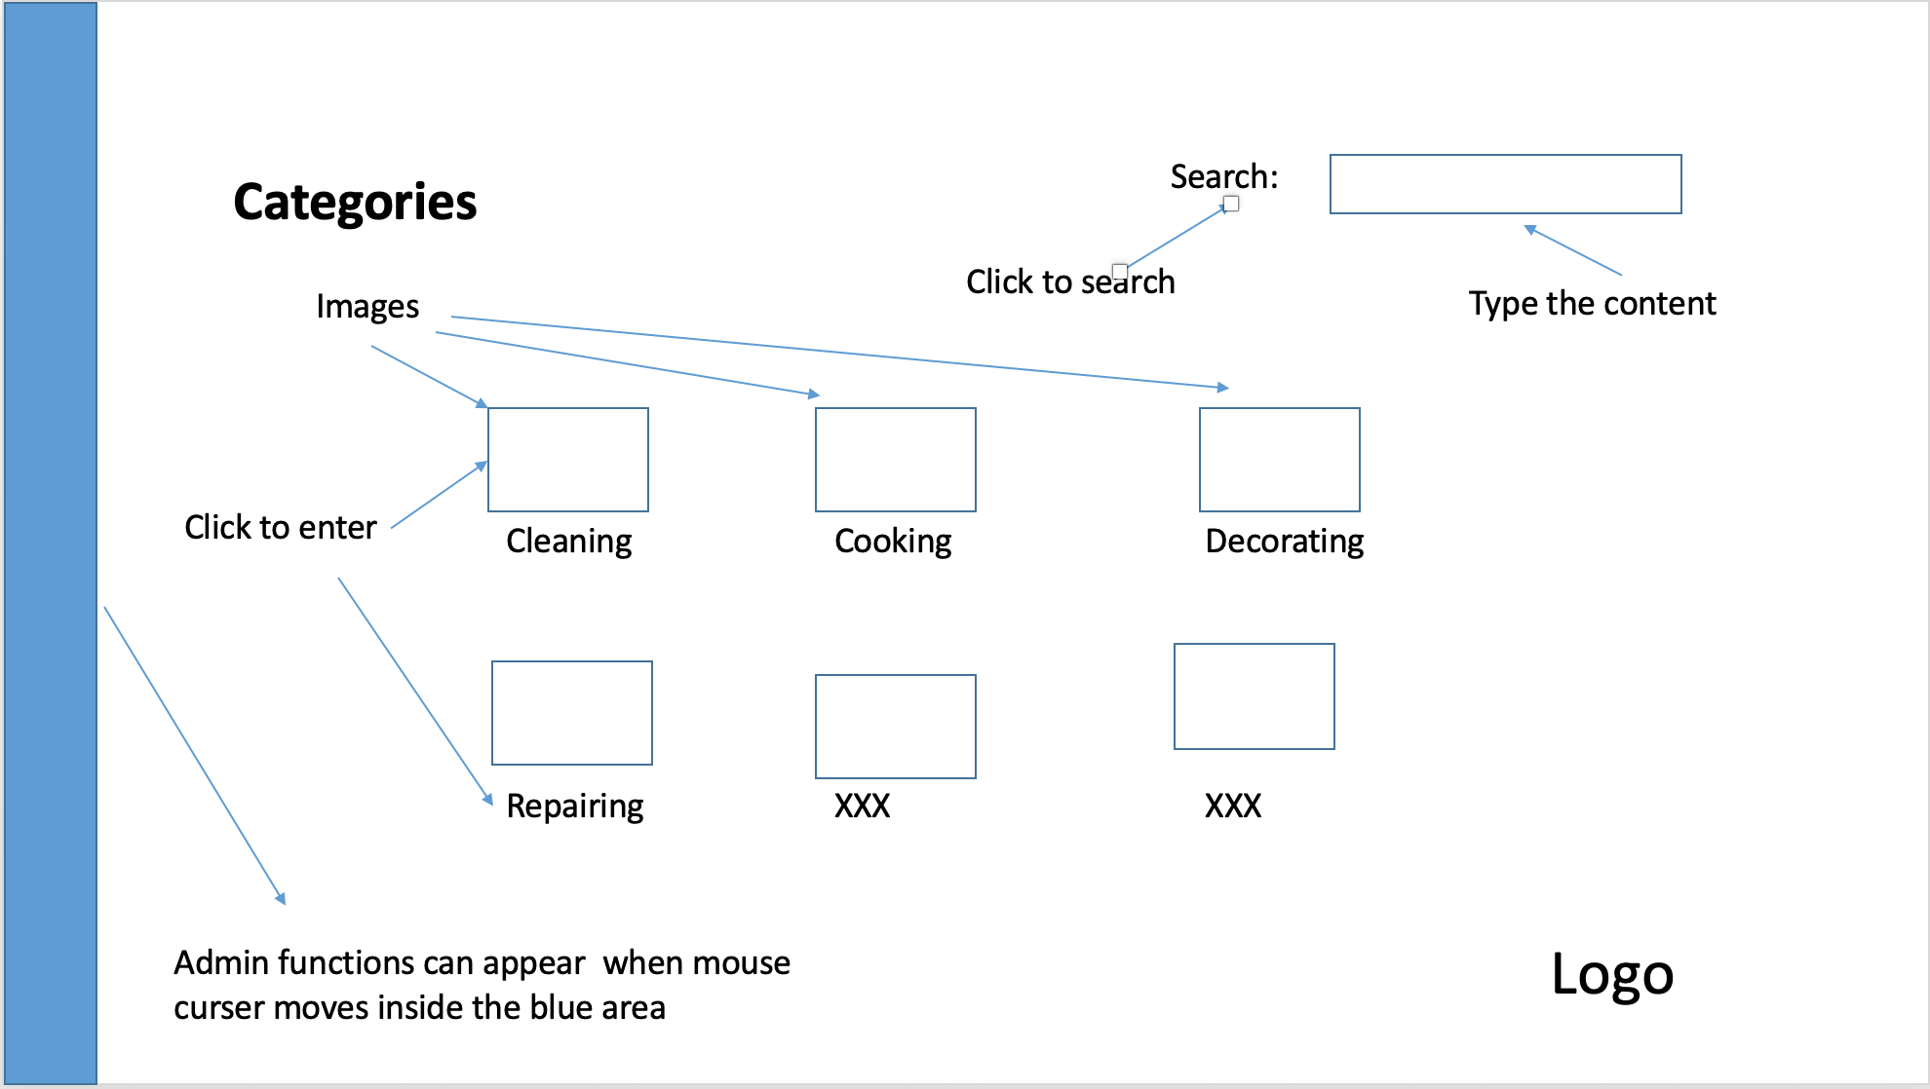

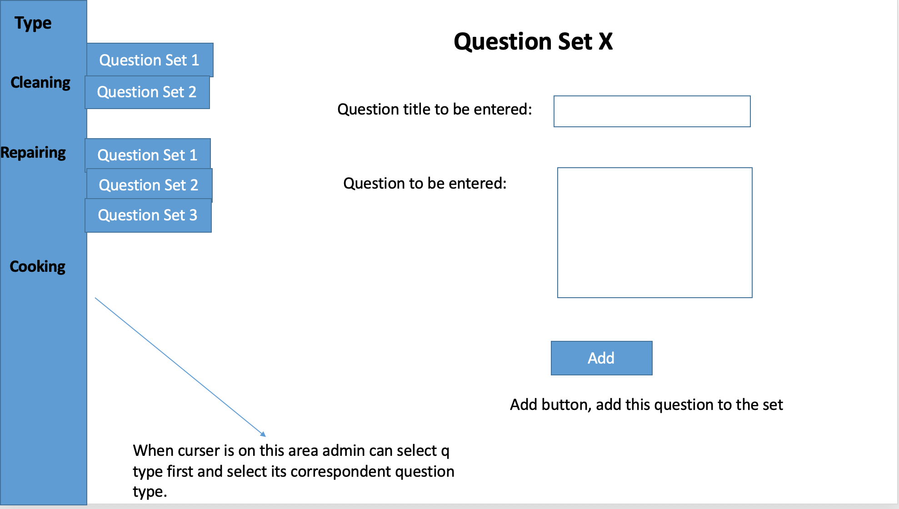

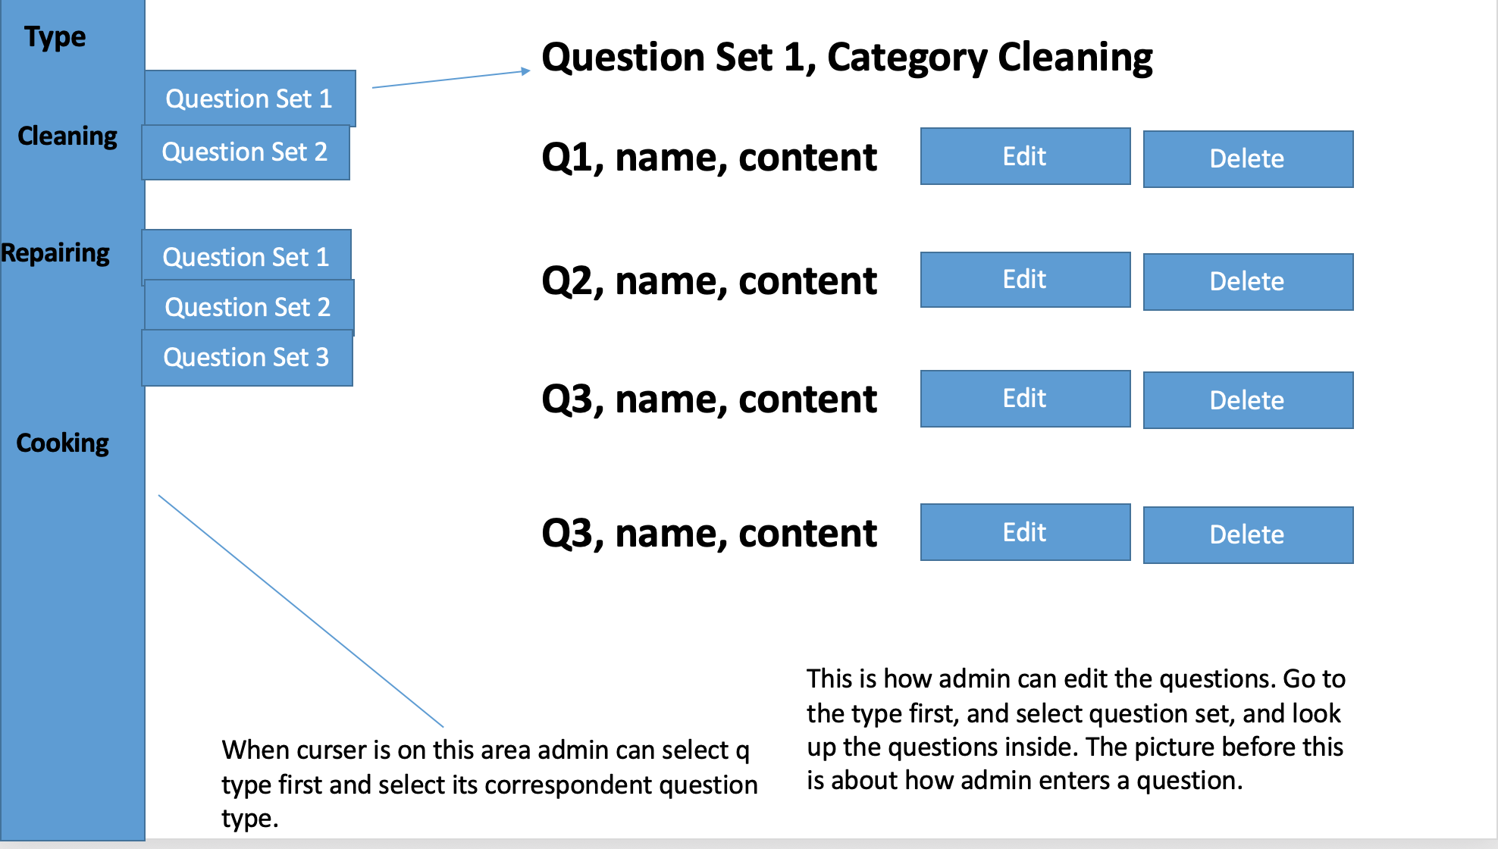

## Navigation Map

[Show a diagram or state chart that explains how you get from one screen to another.]

# PROJECT CONTROLS

## Use Case Prioritization

|  |  |  |  |  |  |  |
| --- | --- | --- | --- | --- | --- | --- |
| ID | Stakeholder Value | Business Value | Architectural Impact | Technical Risk | Priority Score | Rank |
|  |  |  |  |  |  |  |
|  |  |  |  |  |  |  |
|  |  |  |  |  |  |  |

## Risks

|  |  |  |  |  |  |
| --- | --- | --- | --- | --- | --- |
| ID | Risk | Probability | Impact | Score | Strategy |
|  |  |  |  |  |  |
|  |  |  |  |  |  |
|  |  |  |  |  |  |

## Issues

|  |  |  |  |  |
| --- | --- | --- | --- | --- |
| ID | Issue | Description | Owner | Status |
|  |  |  |  |  |
|  |  |  |  |  |
|  |  |  |  |  |

## Schedule

[Place your schedule and Gantt chart here from your project management tool. List who is responsible for what work, perhaps use a WBS.]

## Cost Estimate

[Estimate the cost of the project based on the resource allocation and WBS. Explain any assumptions you are making in the estimation process.]

## References

[List any references you used and any sources that need to be cited.]

# REQUIREMENTS APPROVALS

**Prepared By** __________________________________

([**Job Title**])

**Approved By** __________________________________

([**Job Title**])

__________________________________

([**Job Title**])

__________________________________

([**Job Title**])

**Approval Date** __________________________________

# APPENDICES

## Source Material